# **Name: Abdurrahman Qureshi**

# **Roll No: 242466**

Practical No: 7

Executing UNIX Commands in Vi Editor.

1. Vi

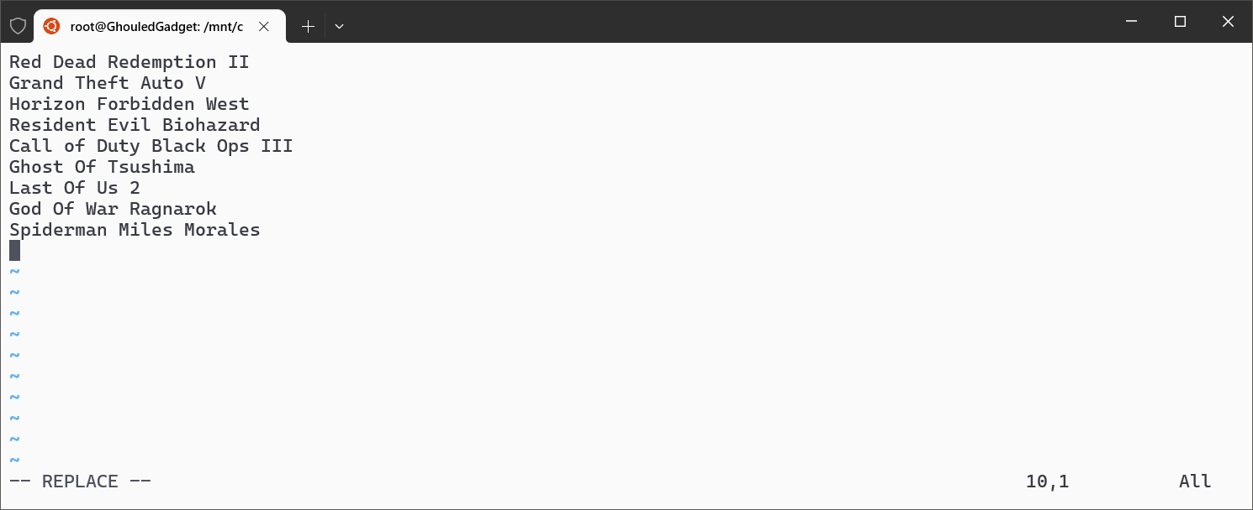

1. Displaying the content of the file using “cat” command

